Discover Singapore with INTRO TRAVELS INDIA
Singapore is one of Asia’s most modern and exciting travel destinations, famous for its futuristic skyline, luxury shopping, world-class attractions, beautiful gardens, delicious food, and family-friendly experiences. Despite being a small island nation, Singapore offers a perfect mix of culture, entertainment, adventure, and luxury.
Whether you are planning a honeymoon, family vacation, solo trip, or group holiday, Singapore promises an unforgettable international travel experience.

Why Visit Singapore?
- Safe, clean, and modern city
- World-famous attractions & theme parks
- Luxury shopping & nightlife
- Beautiful gardens & waterfronts
- Multicultural food paradise
- Family-friendly destination
- Excellent public transport
- Perfect combination of luxury & adventure

Top Tourist Attractions in Singapore
1. Marina Bay Sands
Singapore’s most iconic luxury destination.
Highlights:
- Infinity rooftop pool
- SkyPark Observation Deck
- Luxury shopping mall
- Spectacular skyline views
- Light & water show
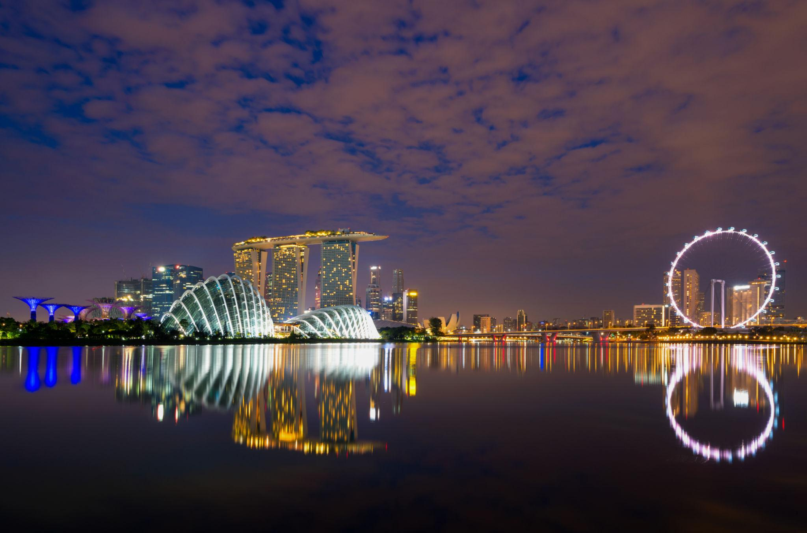
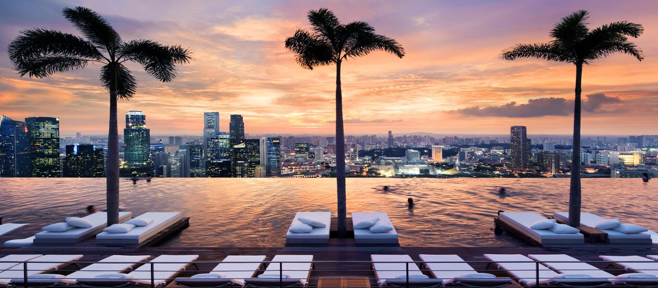
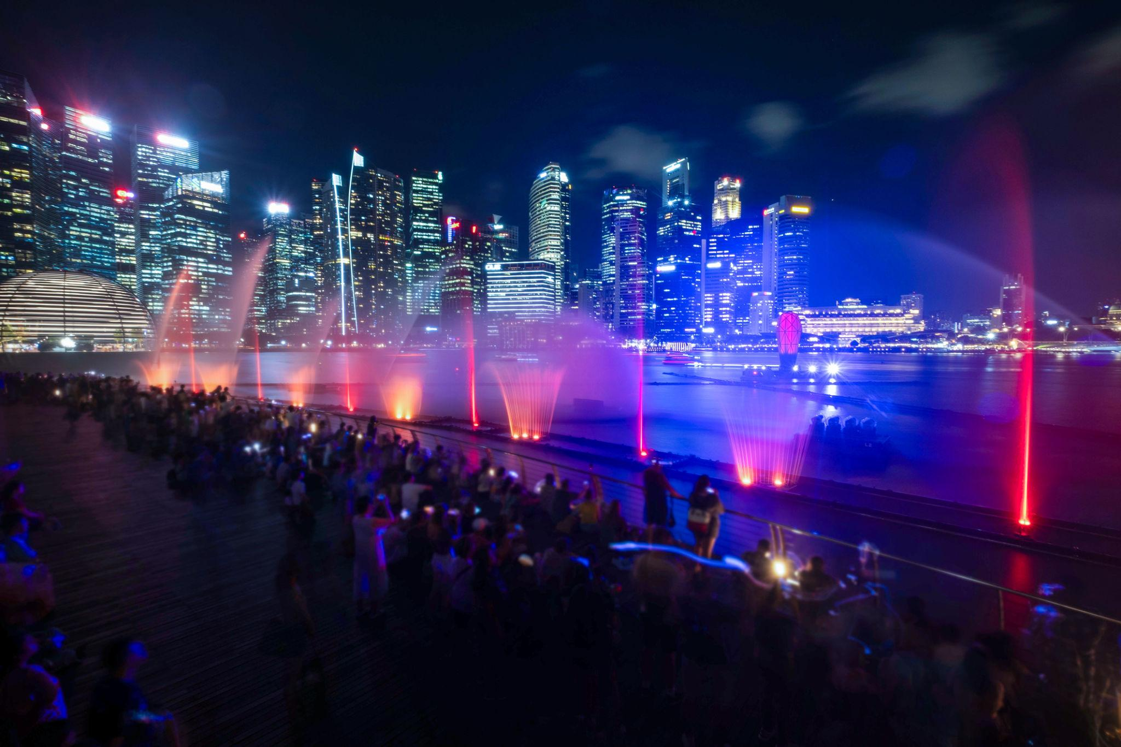
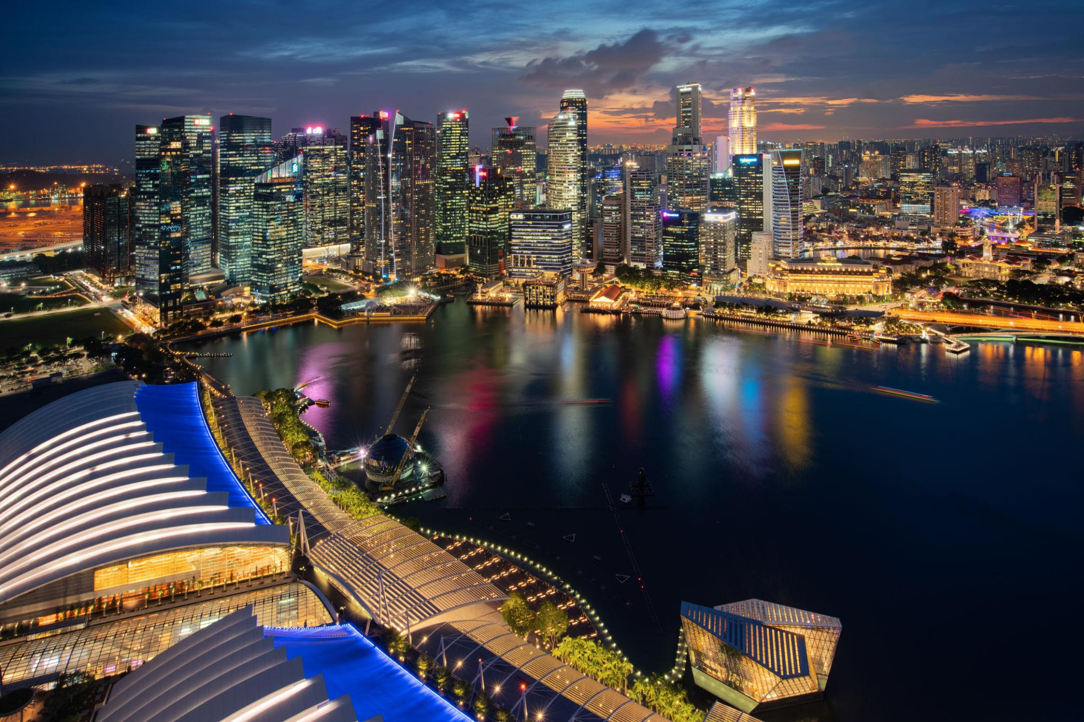
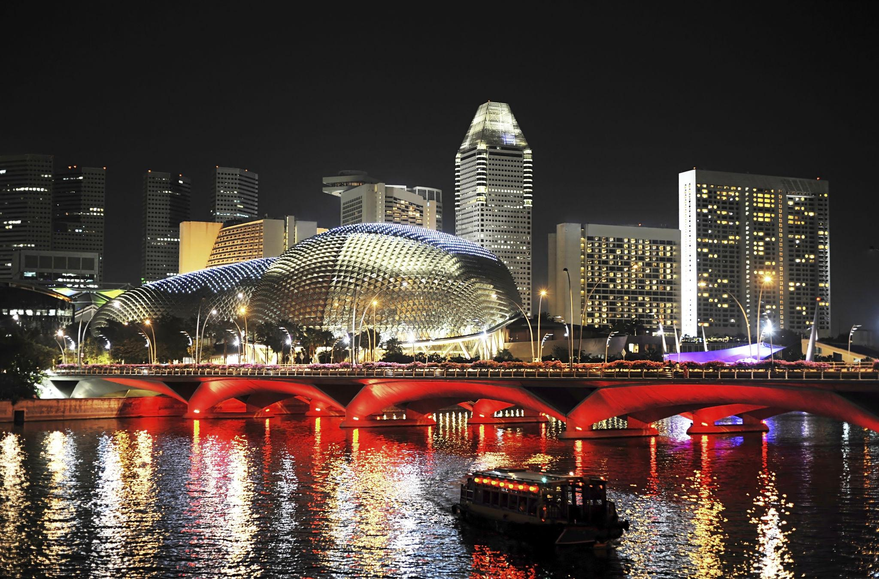


2. Gardens by the Bay
A futuristic nature park famous for giant Supertrees and indoor gardens.
Top attractions:
- Supertree Grove
- Cloud Forest
- Flower Dome
- Garden Rhapsody Light Show
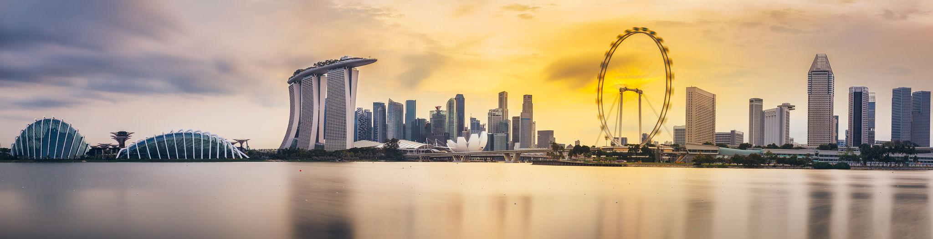
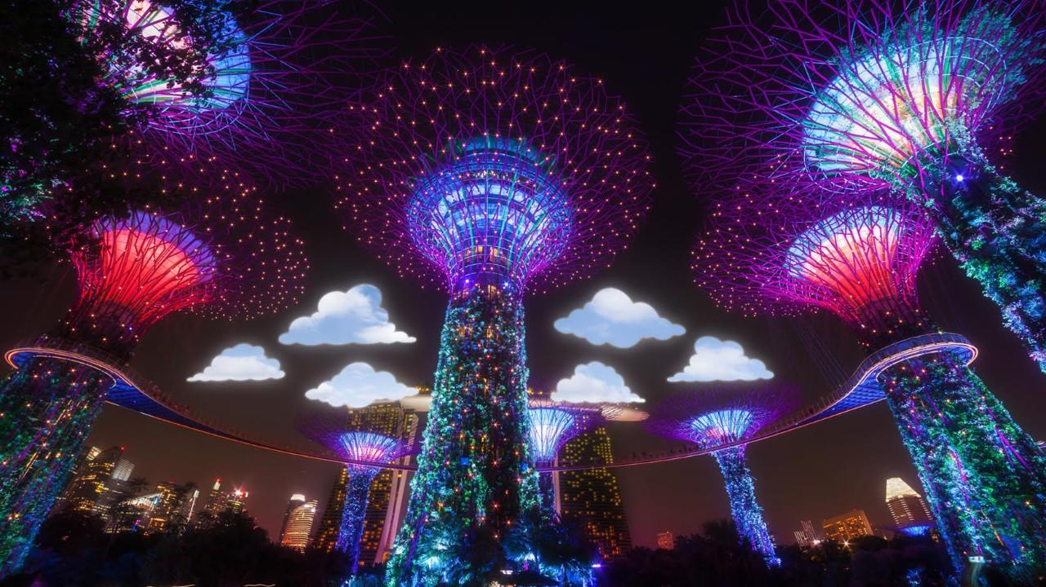

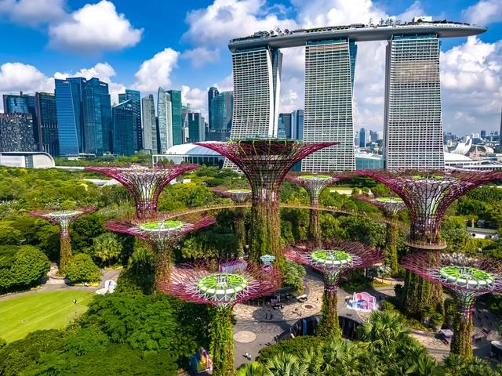
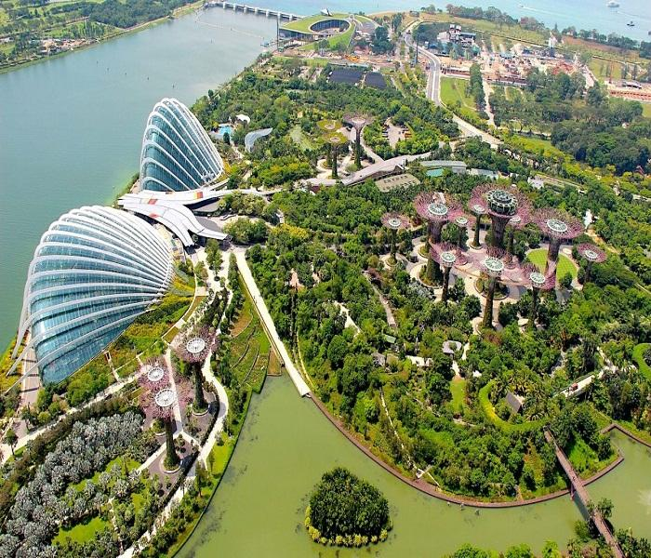



3. Sentosa Island
Singapore’s entertainment and beach paradise.
Best experiences:
- Beaches & resorts
- Adventure parks
- Cable car rides
- Water sports
- Luxury beach clubs
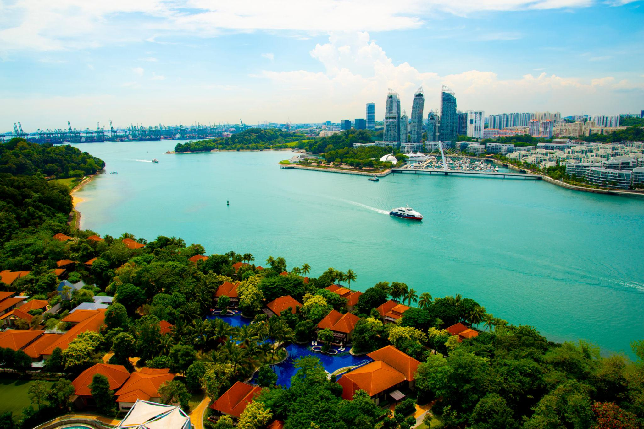
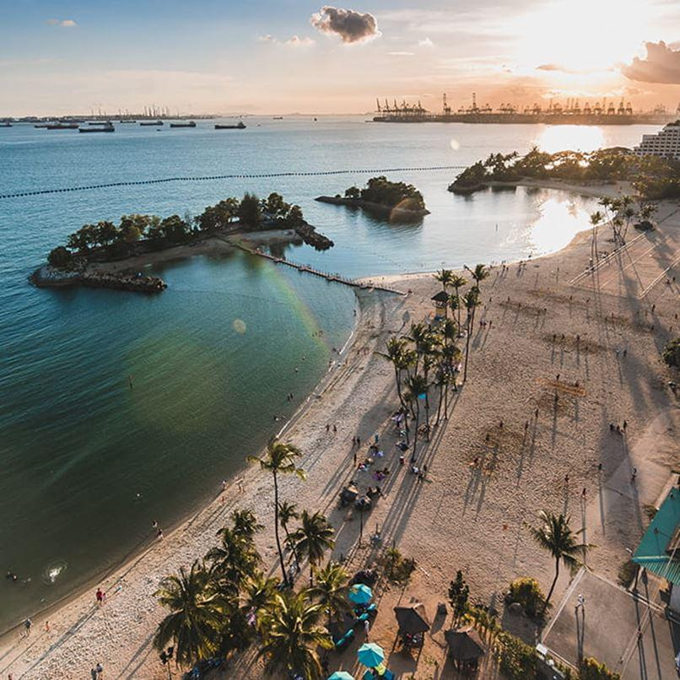
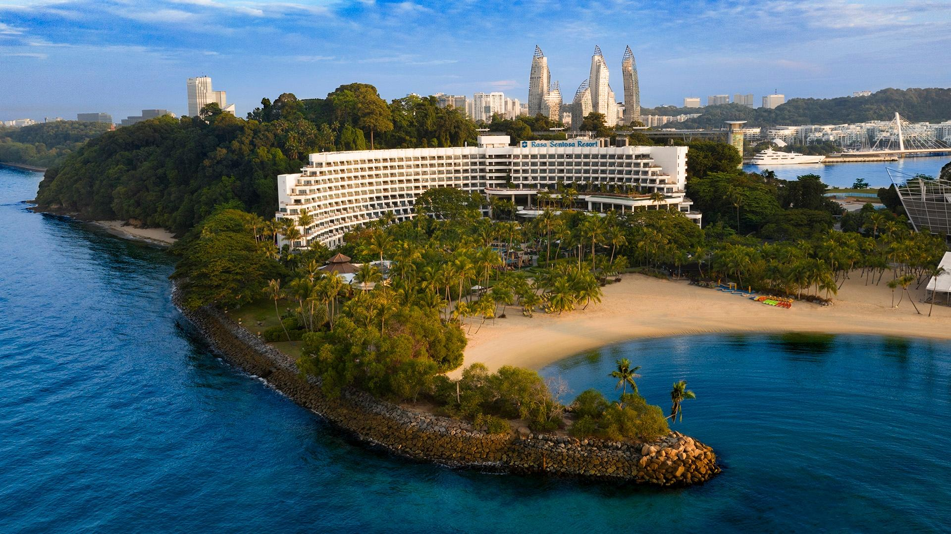
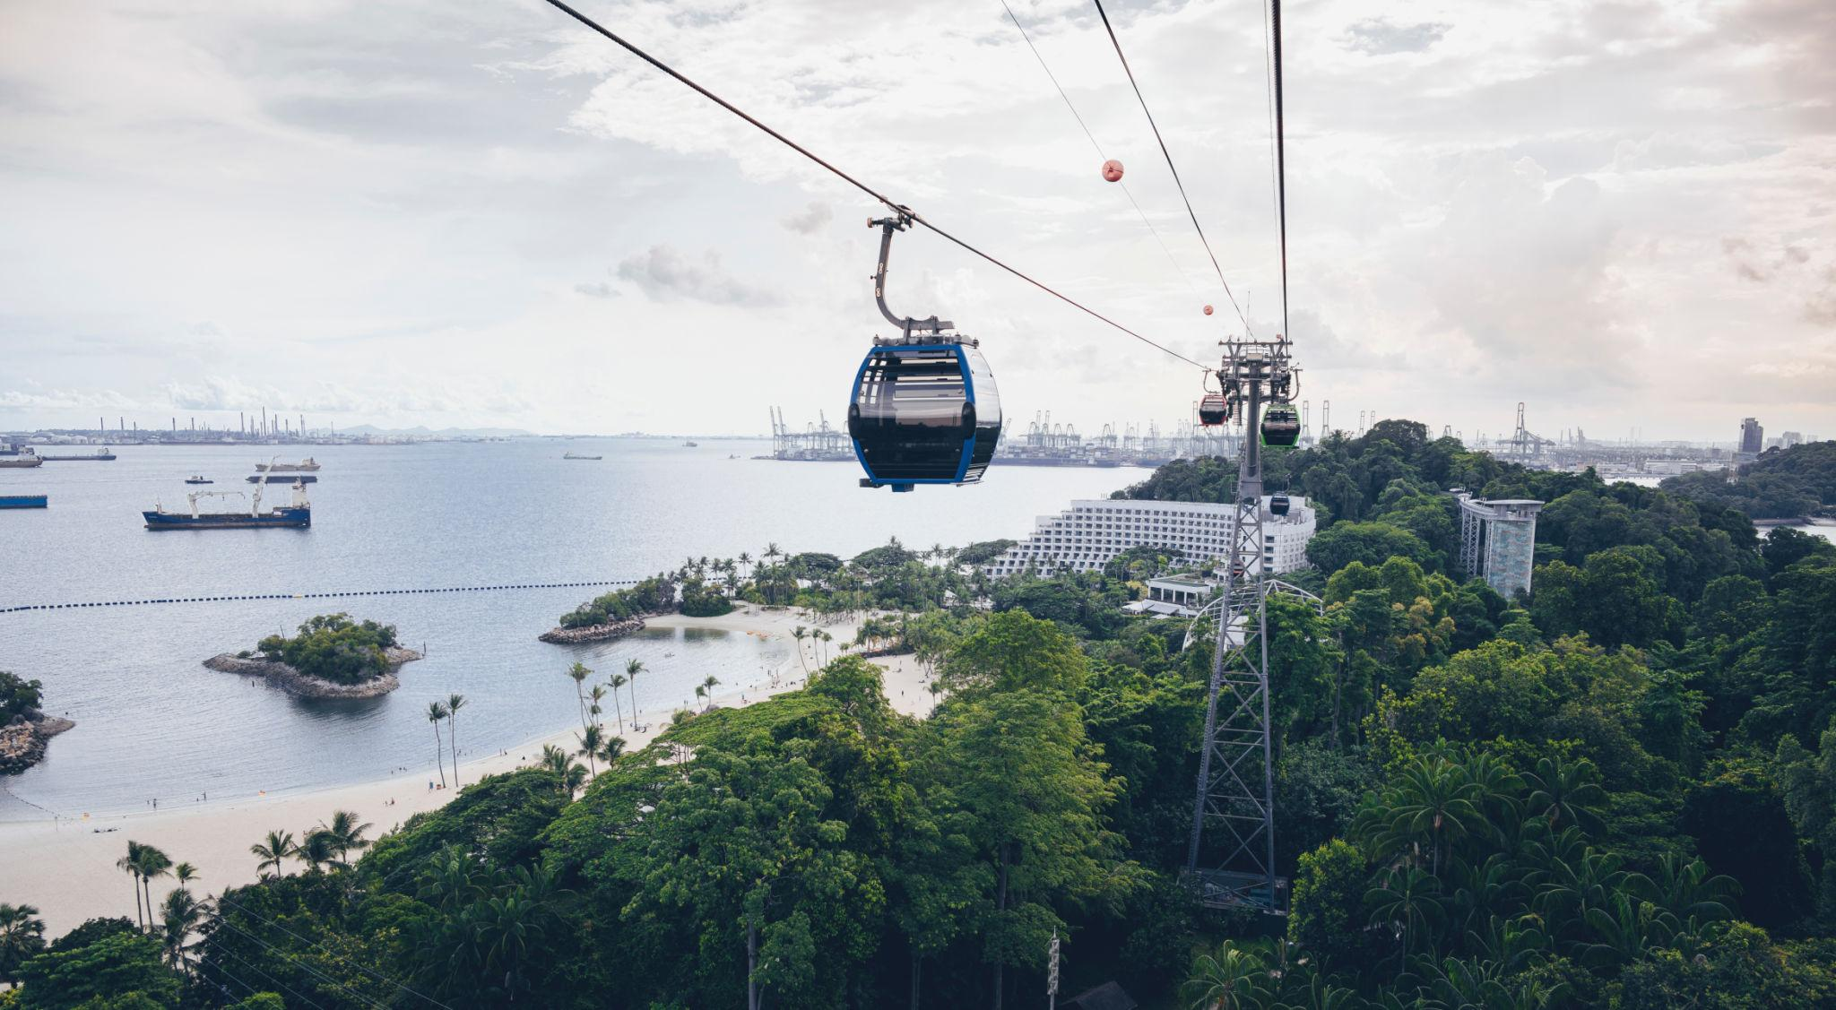
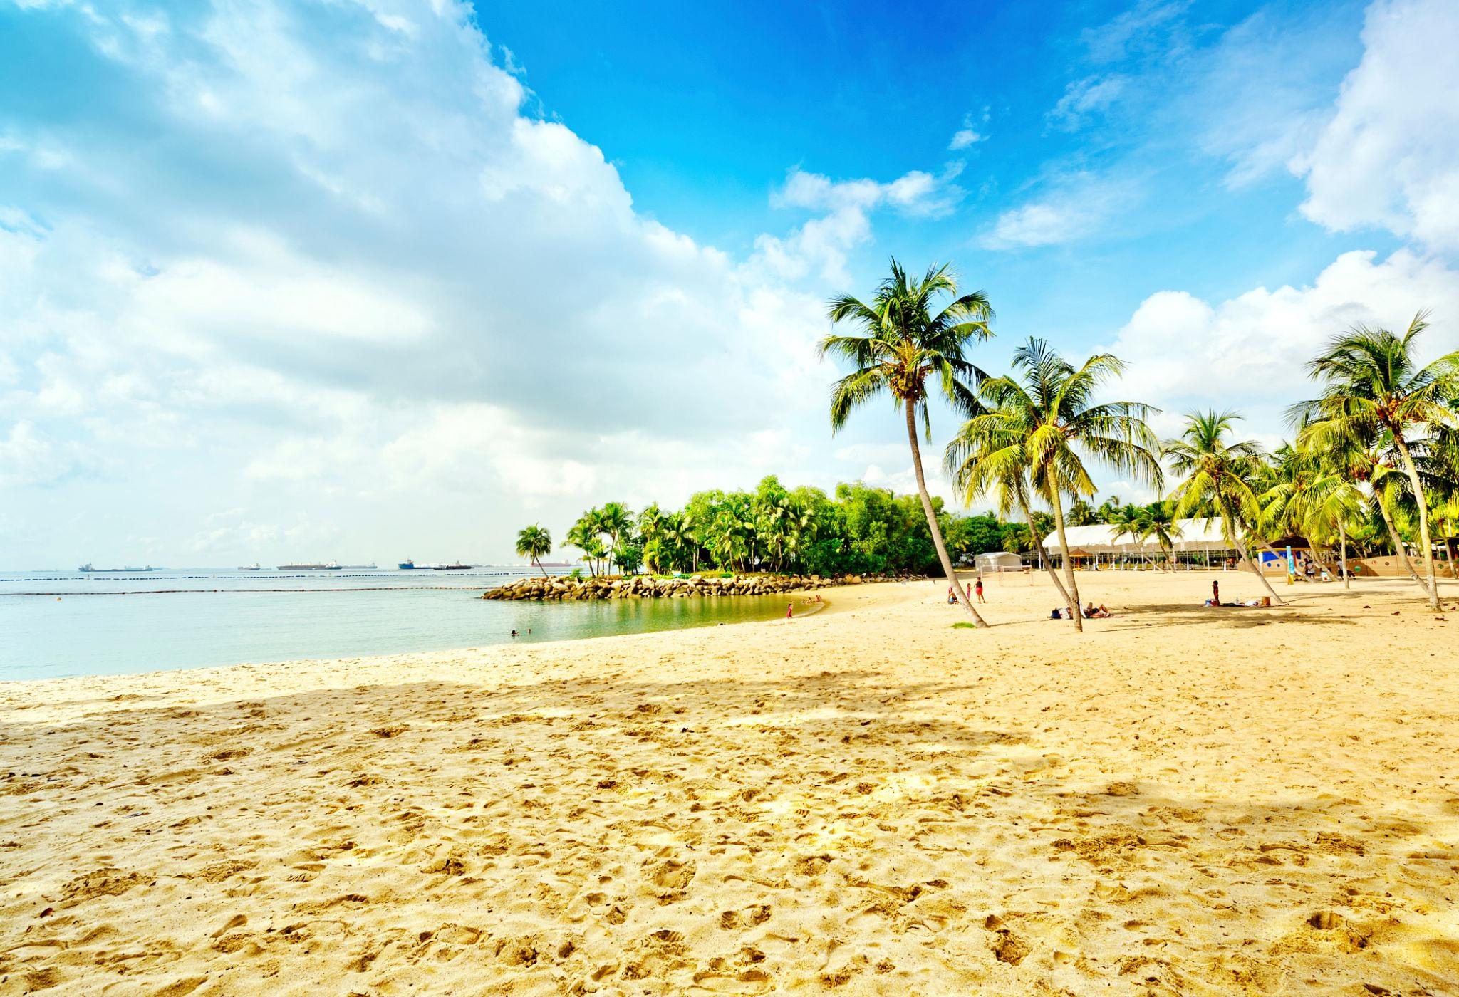

4. Universal Studios Singapore
One of Asia’s best theme parks.
Popular attractions:
- Transformers Ride
- Jurassic Park Rapids
- Hollywood Boulevard
- Family entertainment rides





5. Merlion Park
The symbolic landmark of Singapore featuring the famous Merlion statue.
Best for:
- Skyline photography
- Evening walks
- Marina Bay views
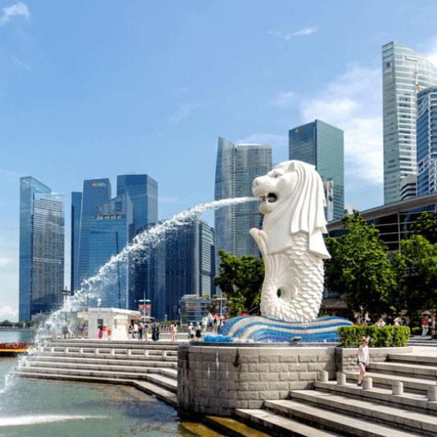
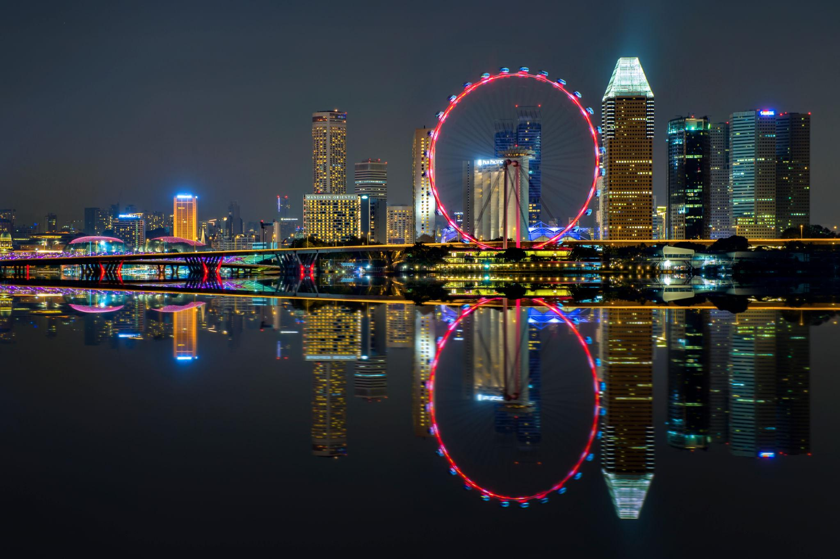
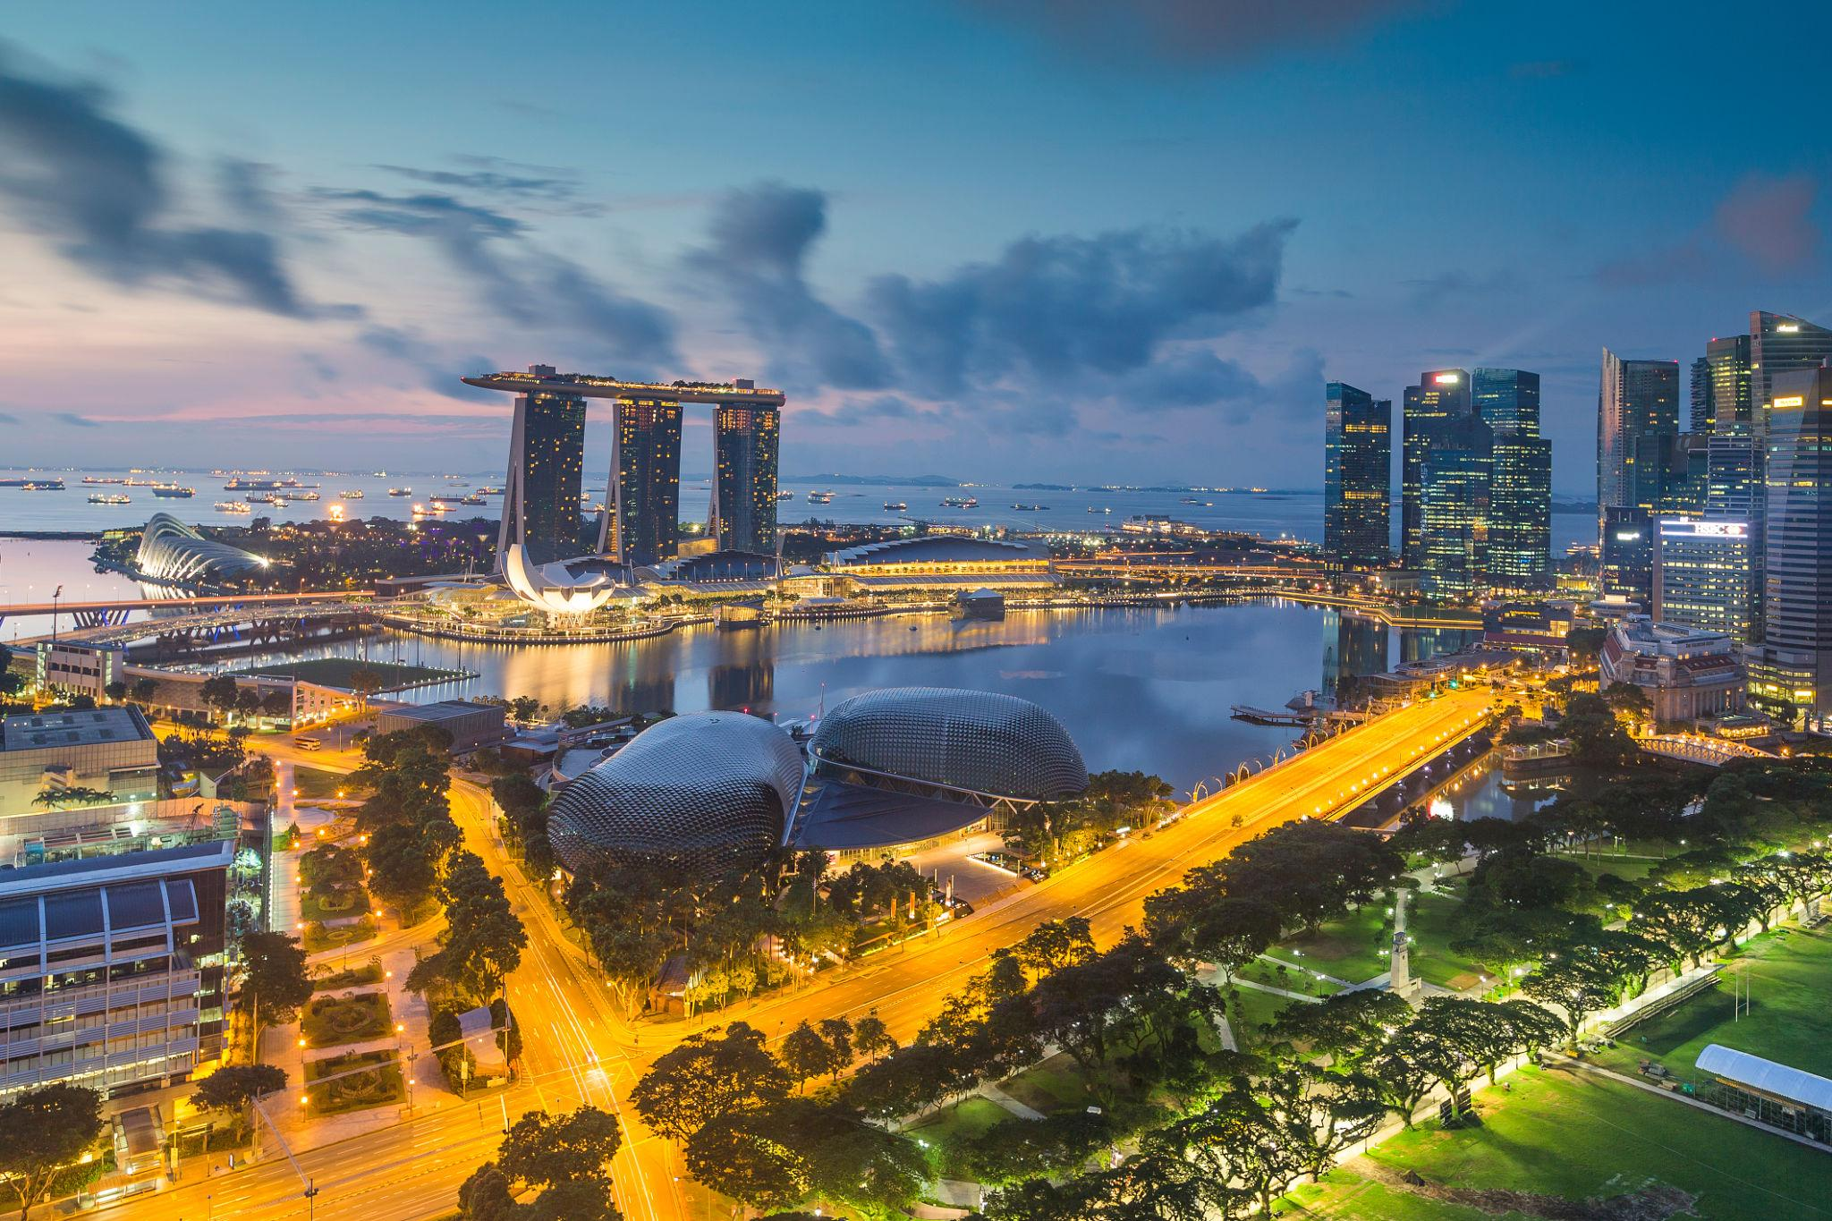
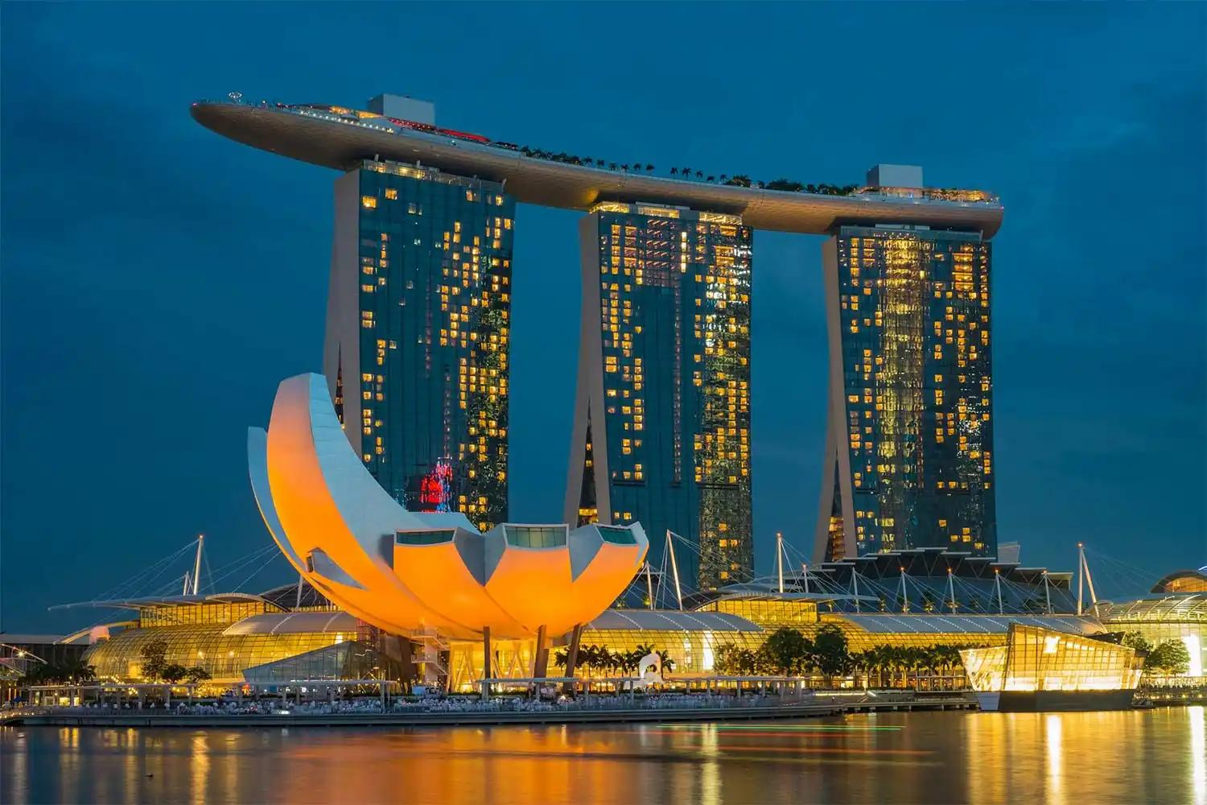
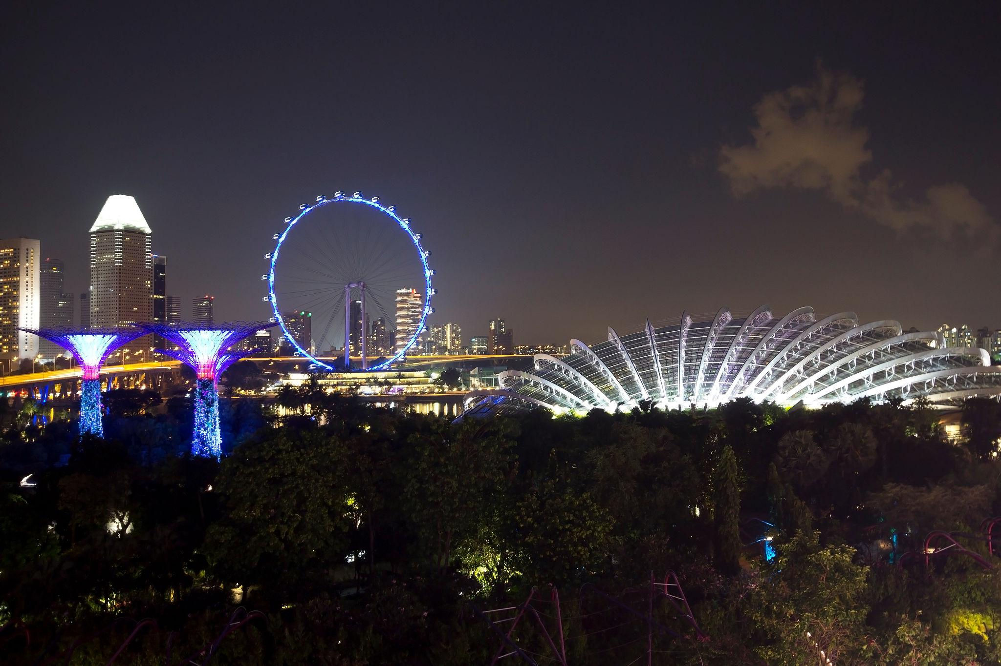

6. Singapore Flyer
One of the world’s largest observation wheels offering stunning city views.
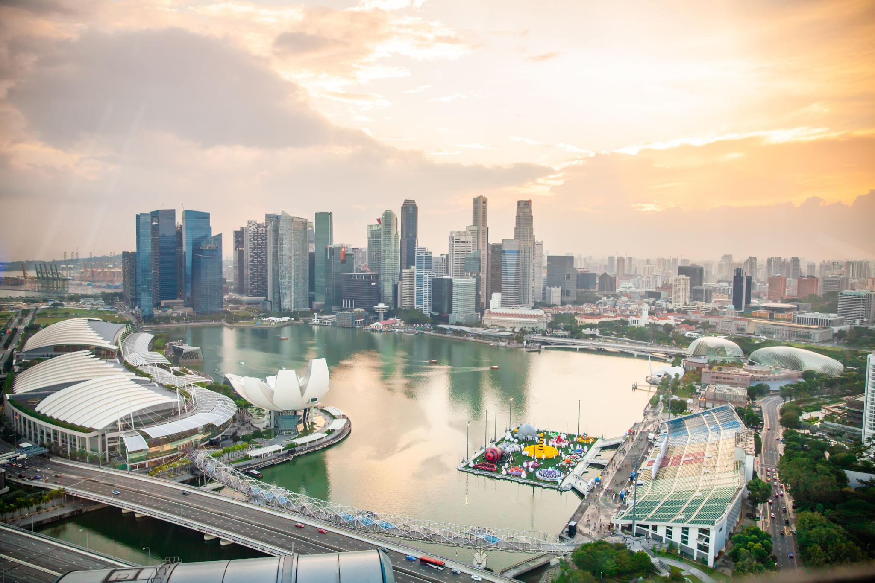
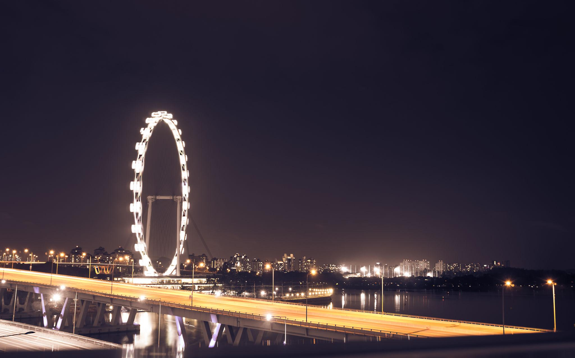
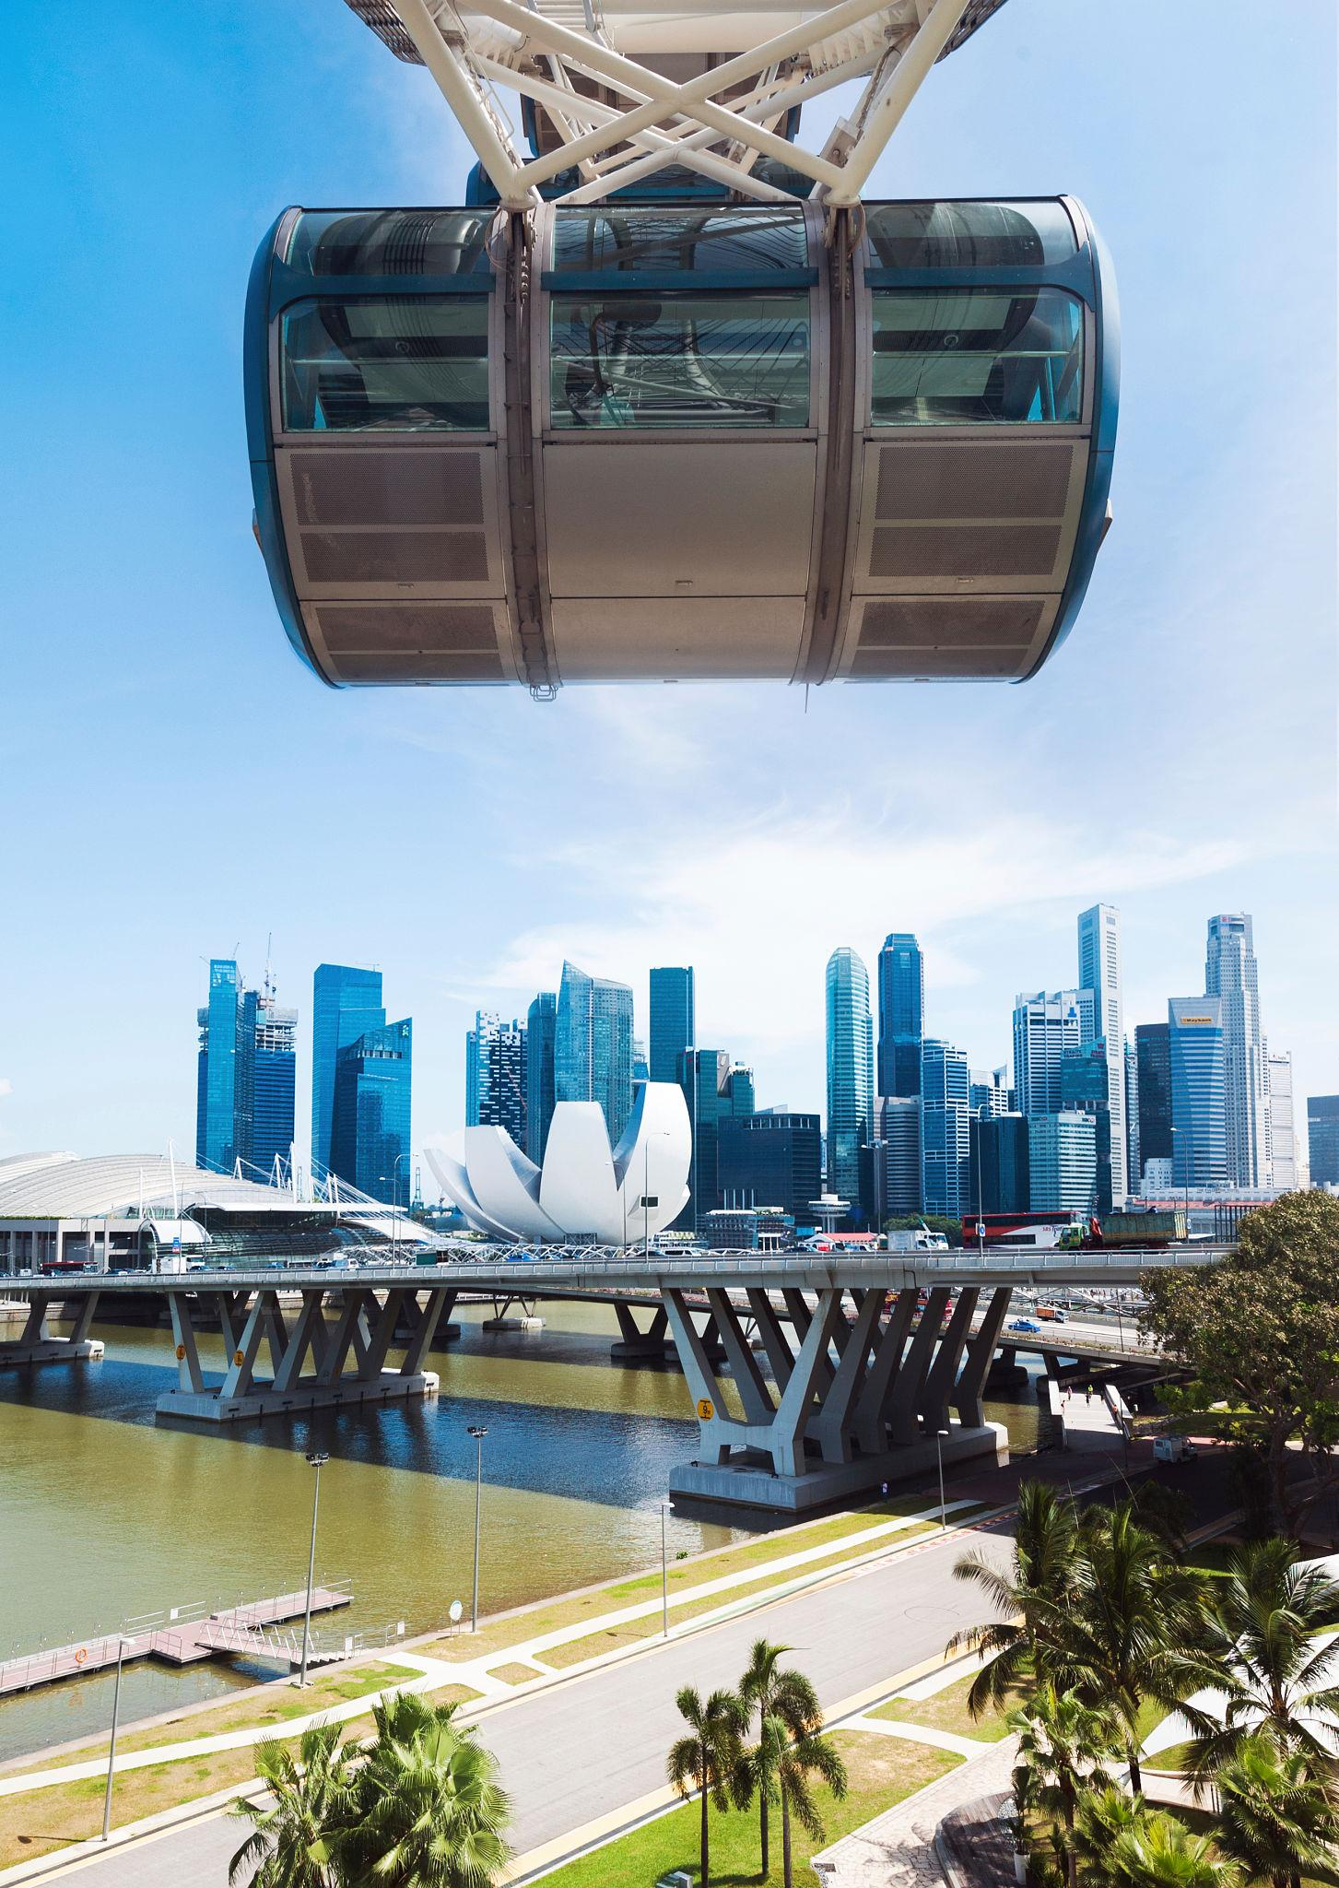
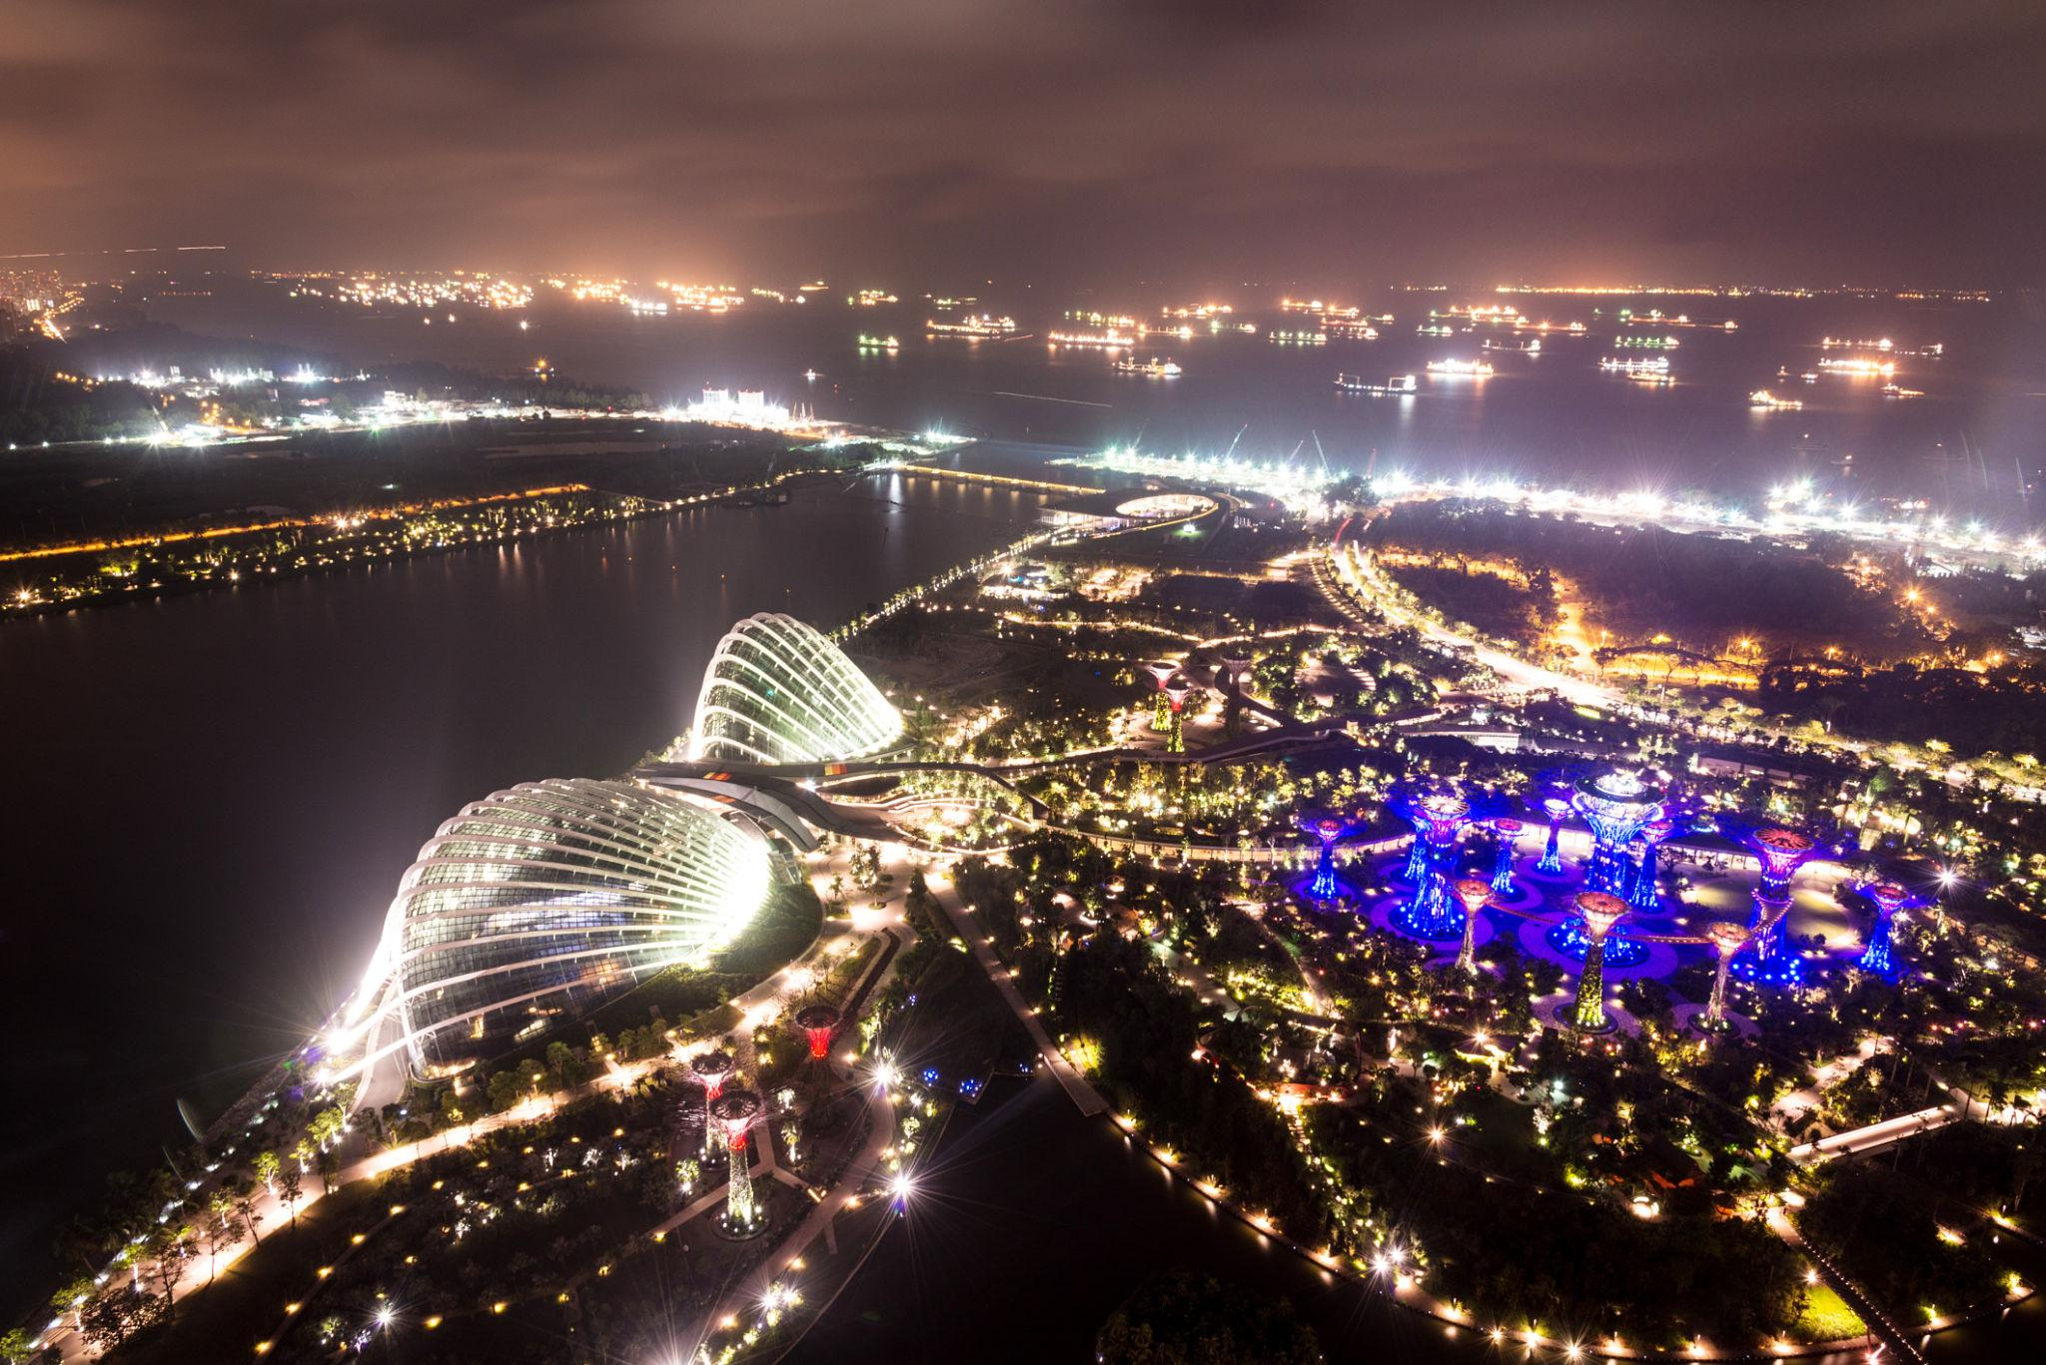
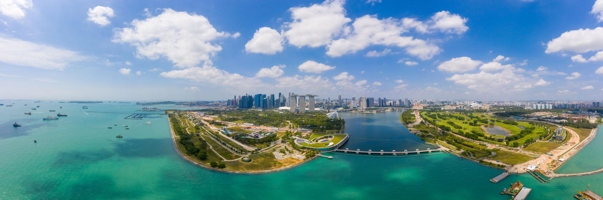
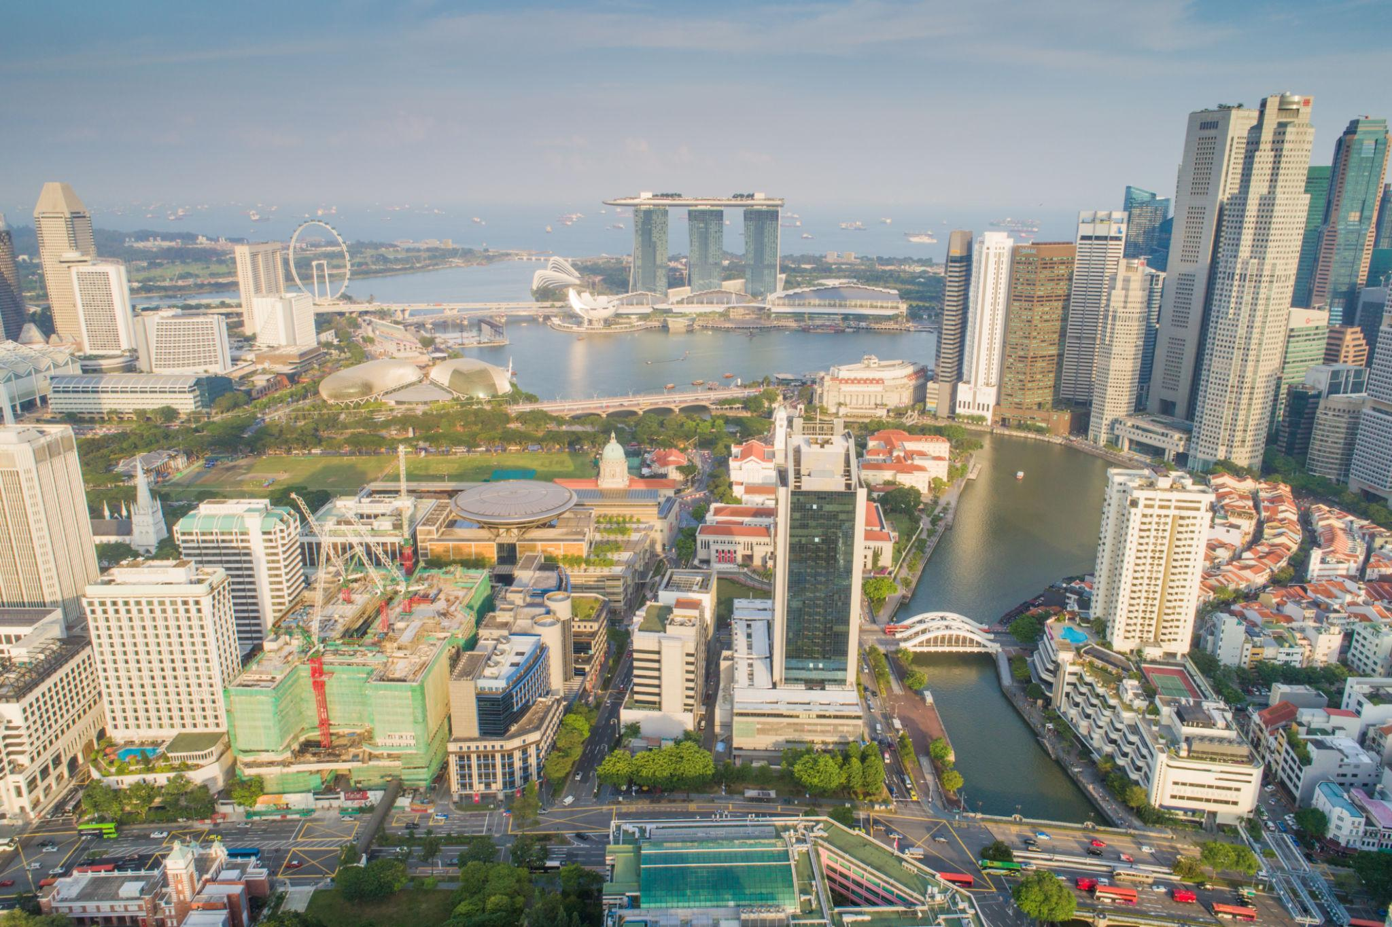

Best Things to Do in Singapore
- Visit Marina Bay Sands SkyPark
- Explore Gardens by the Bay
- Enjoy rides at Universal Studios
- Relax at Sentosa beaches
- Shop at Orchard Road
- Experience Night Safari
- Take Singapore River Cruise
- Visit Chinatown & Little India
- Enjoy rooftop dining & nightlife
- Explore luxury shopping malls

Best Time to Visit Singapore
Season | Months | Weather
Peak Season | December – June | Pleasant weather & festivals
Off Season | July – November | More rain but fewer crowds
Singapore can be visited throughout the year due to its tropical climate.

Singapore Visa for Indians 🇮🇳
Indian travelers generally require:
- Passport valid for 6 months
- Singapore tourist visa
- Return flight tickets
- Hotel bookings
- Travel insurance
Visa processing is usually fast through authorized agents.

Famous Foods to Try in Singapore 🍜
- Hainanese Chicken Rice
- Chilli Crab
- Laksa
- Satay
- Kaya Toast
- Dim Sum
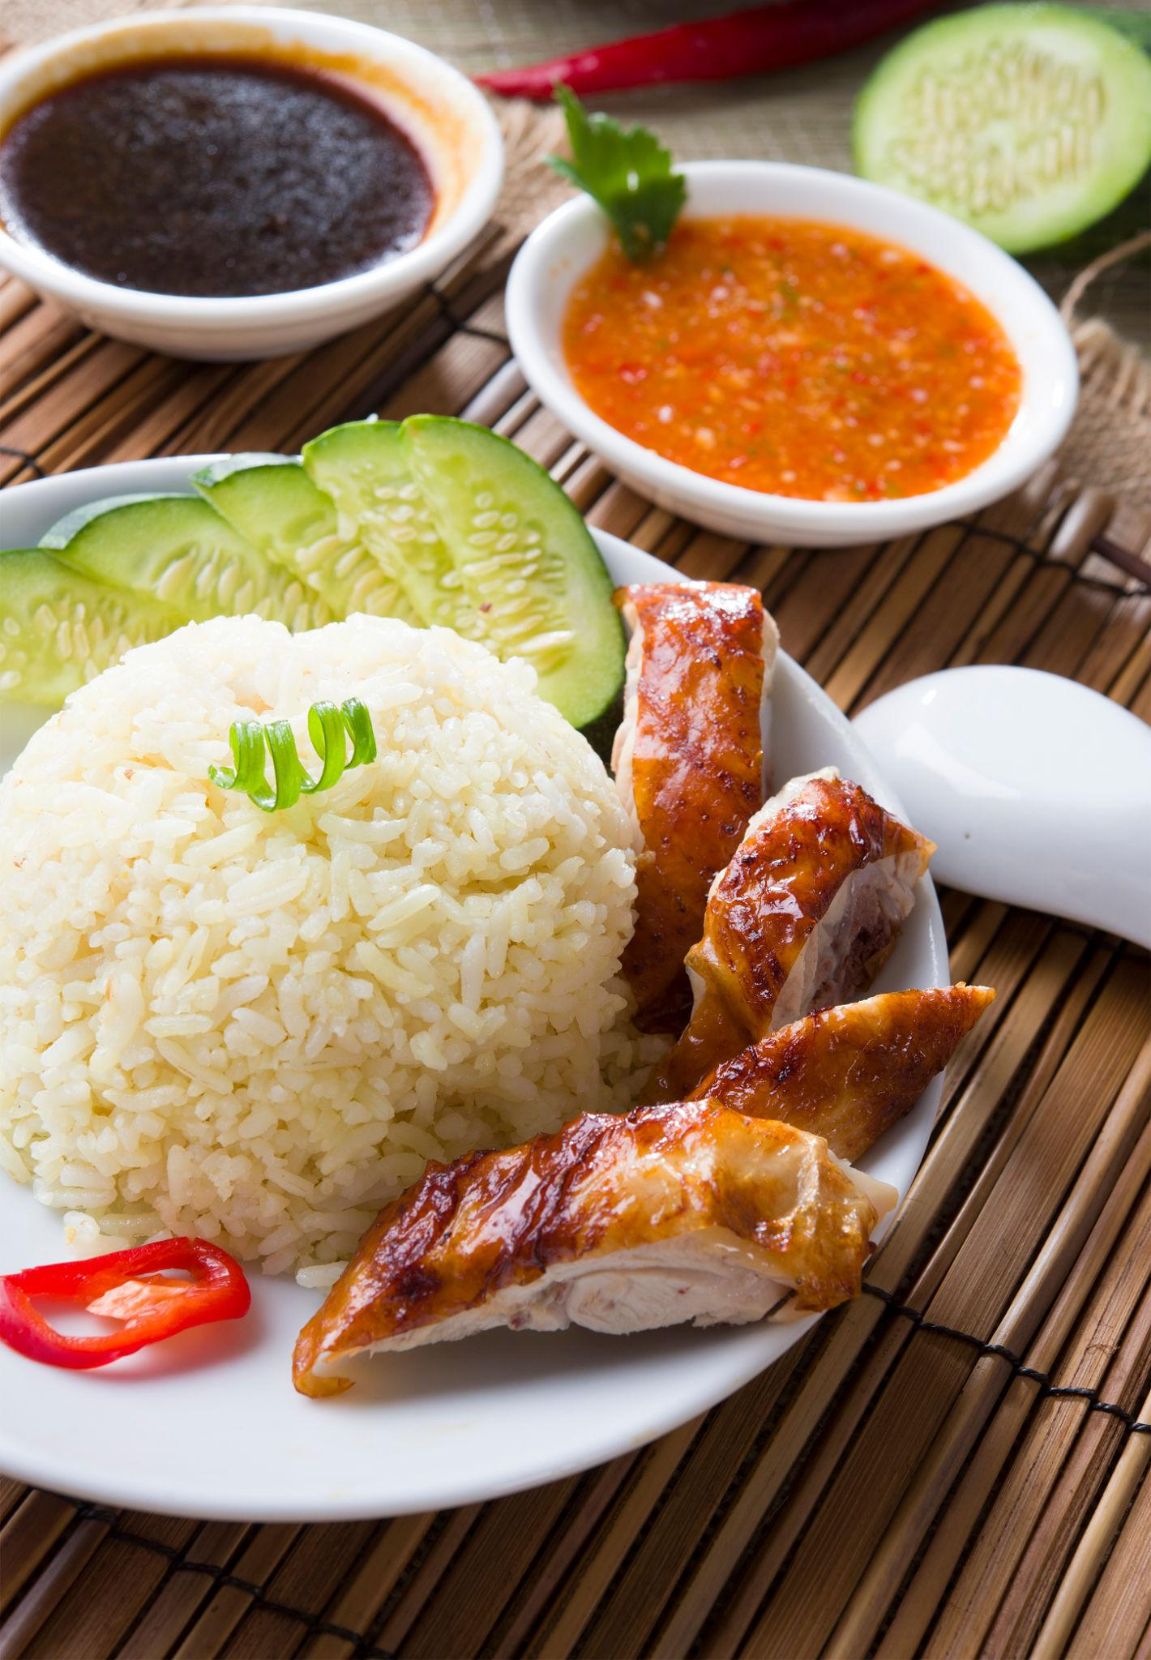
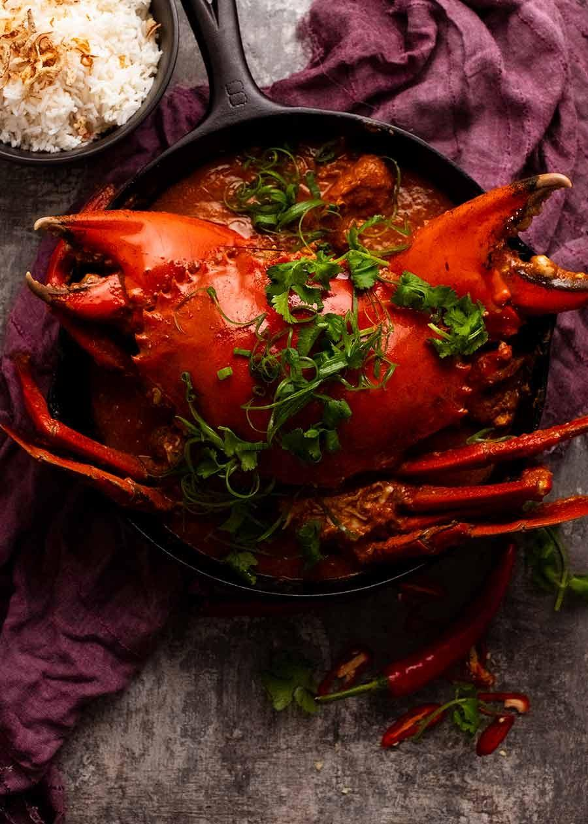
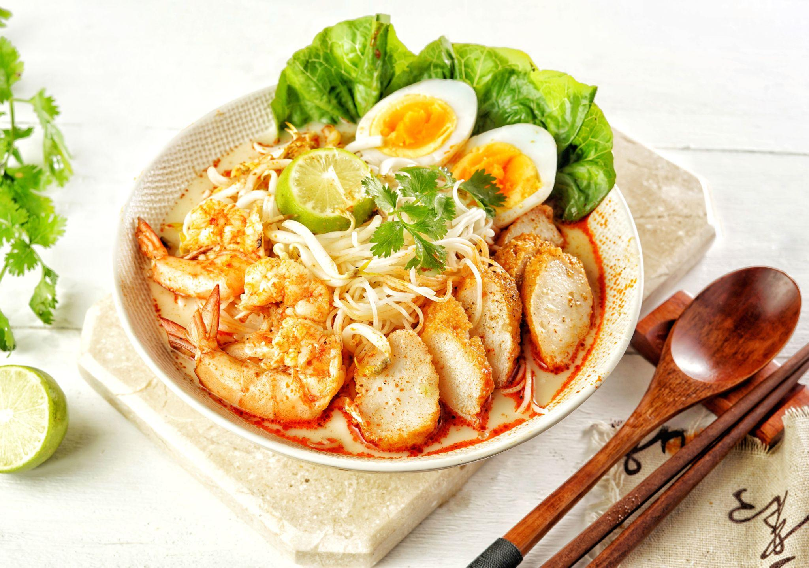
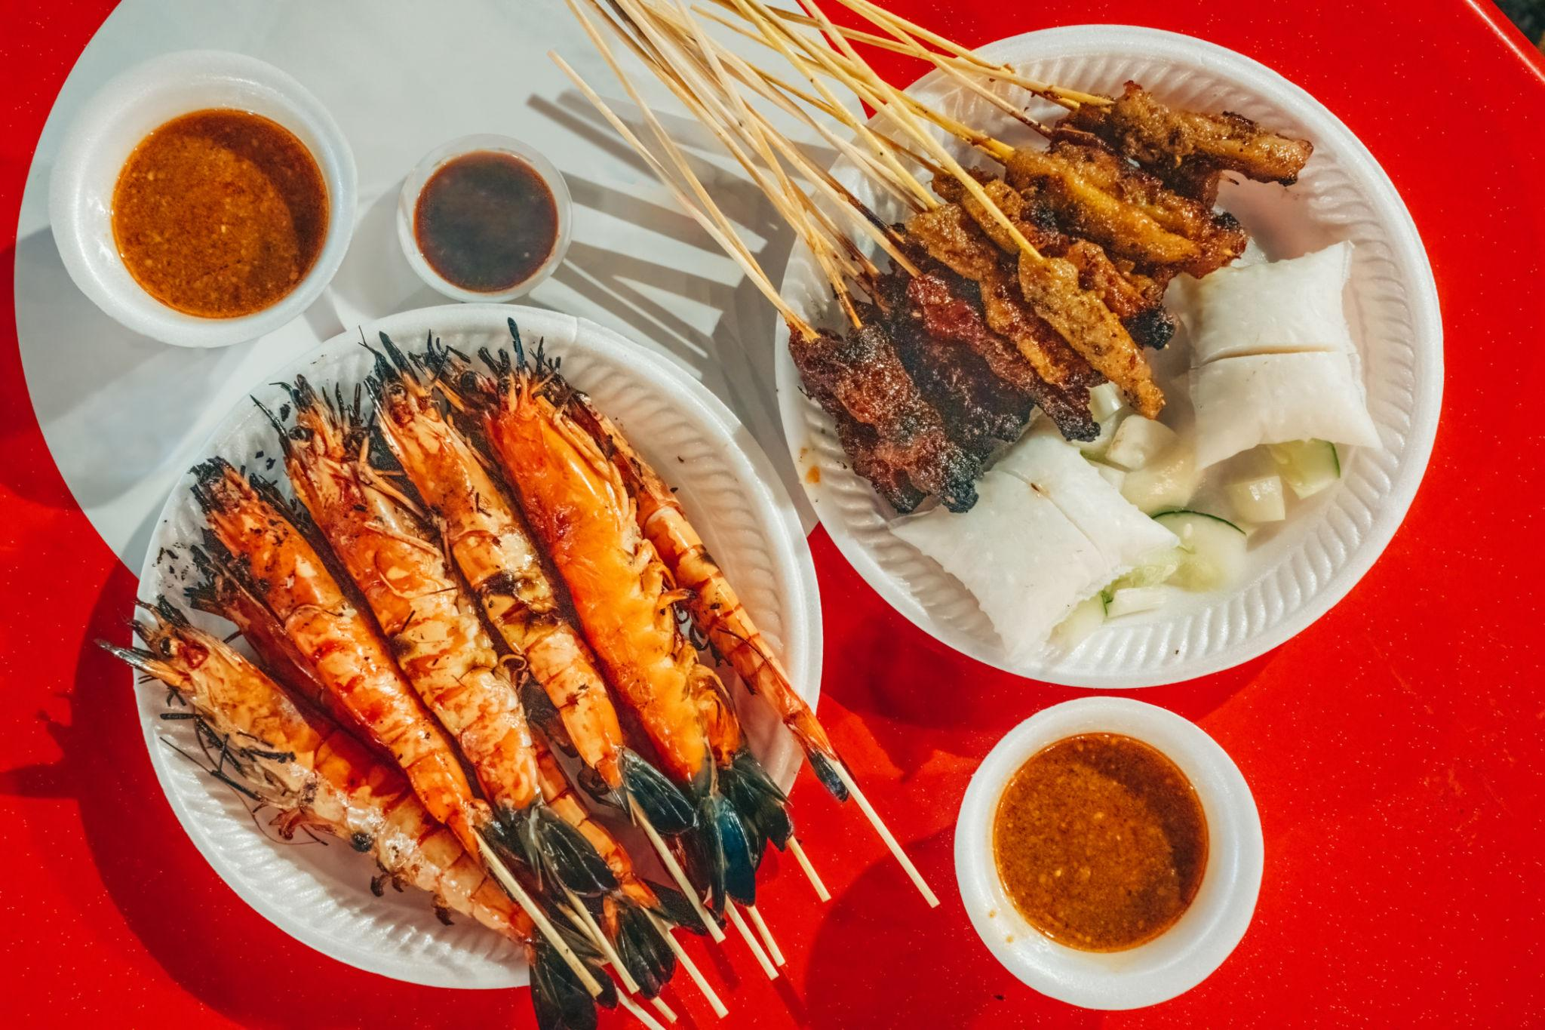
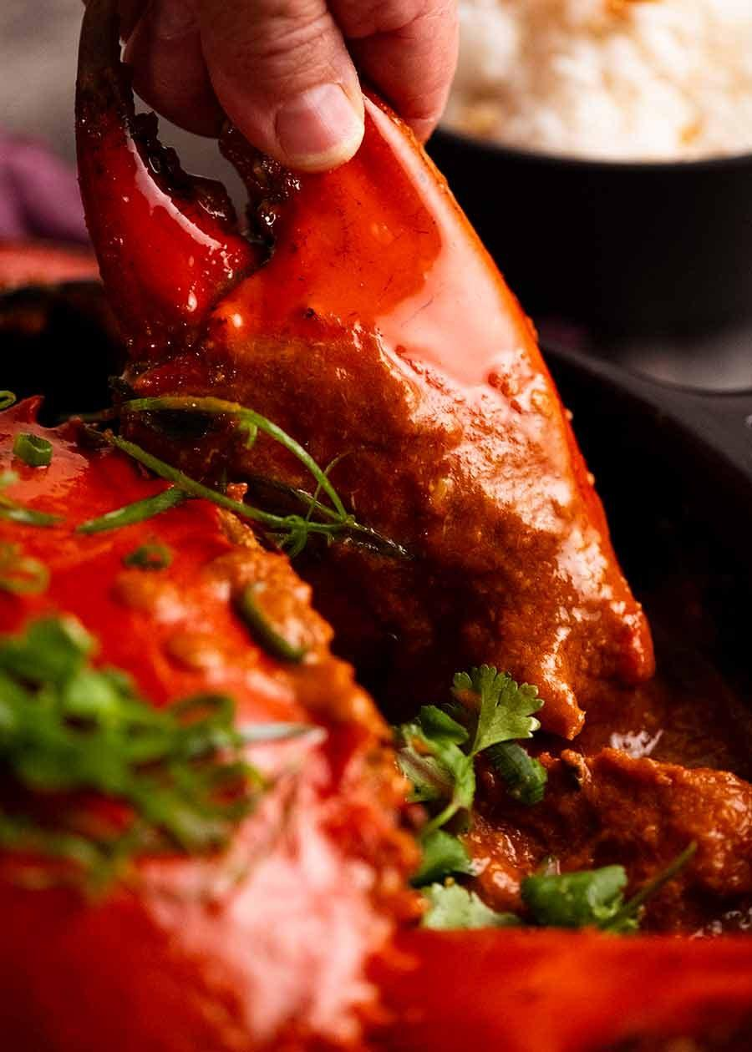
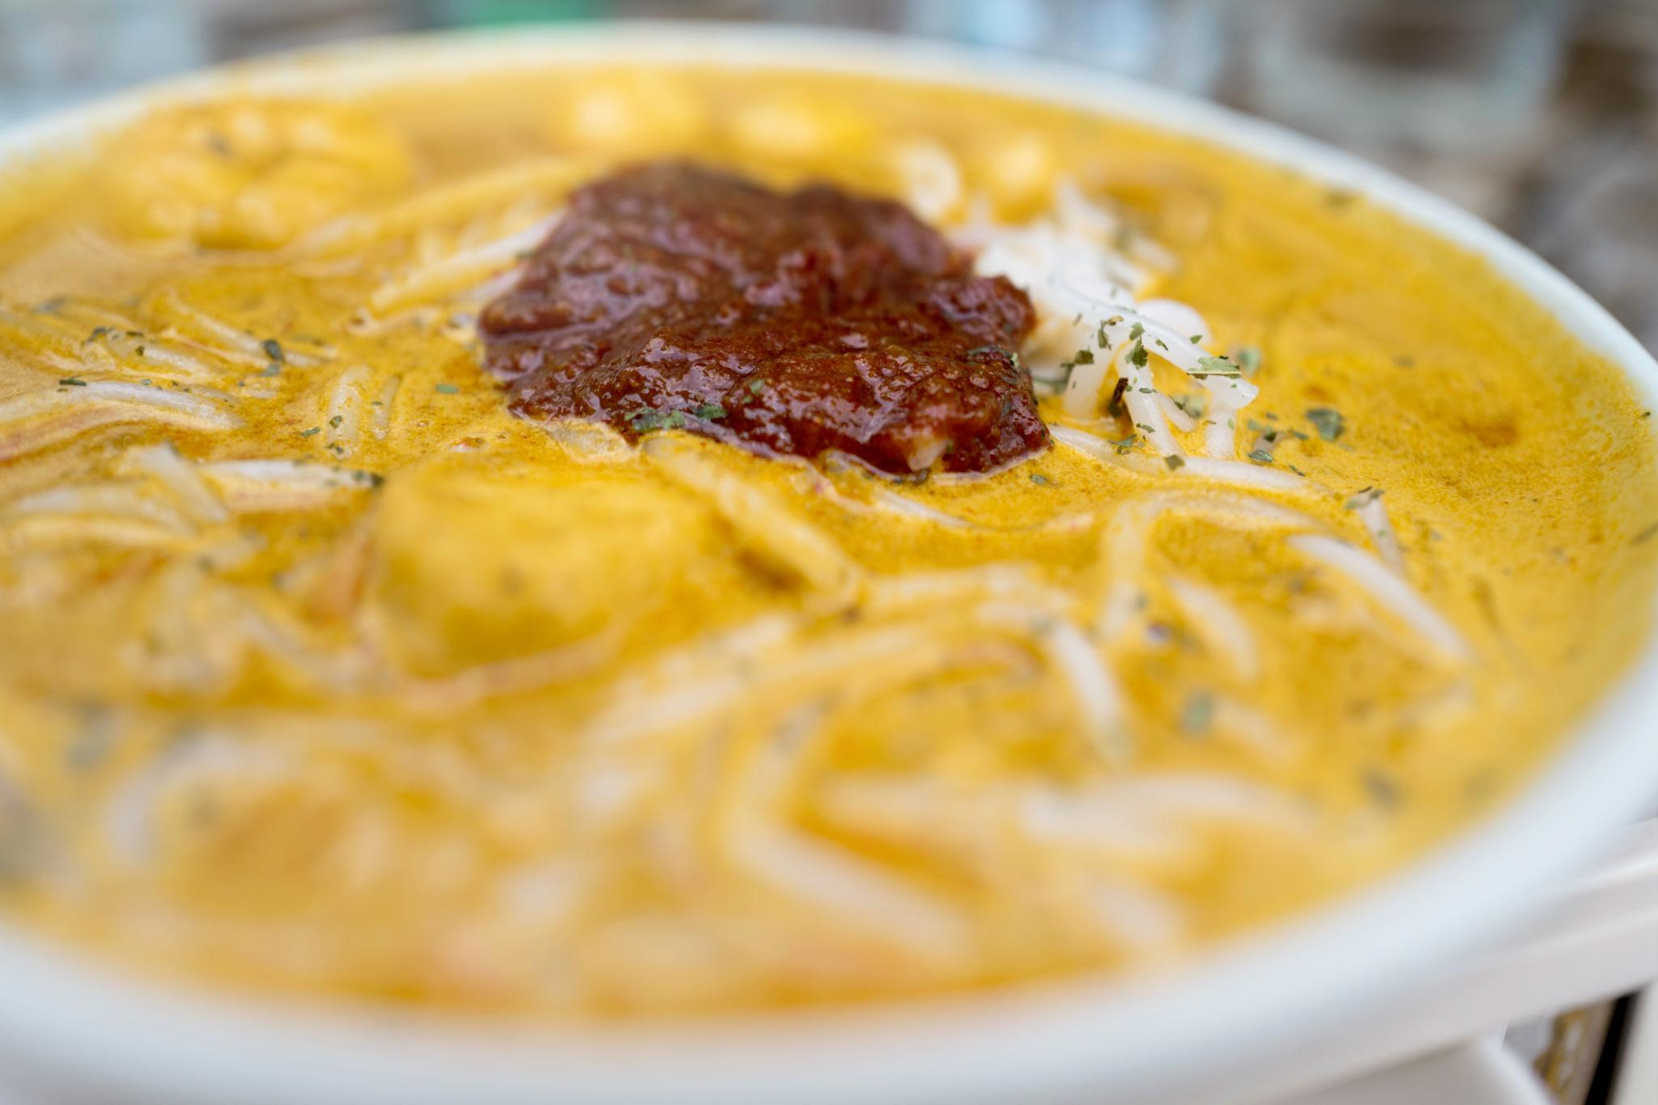

Luxury Experiences in Singapore ✨
- Stay at Marina Bay Sands
- Private yacht cruises
- Fine dining rooftop restaurants
- Luxury shopping at Orchard Road
- VIP Universal Studios experiences
- Helicopter city tours
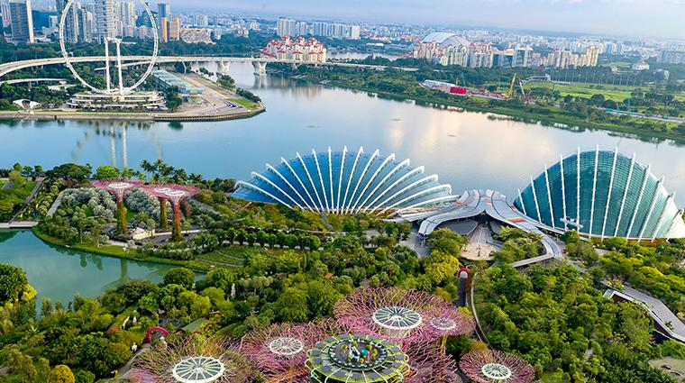
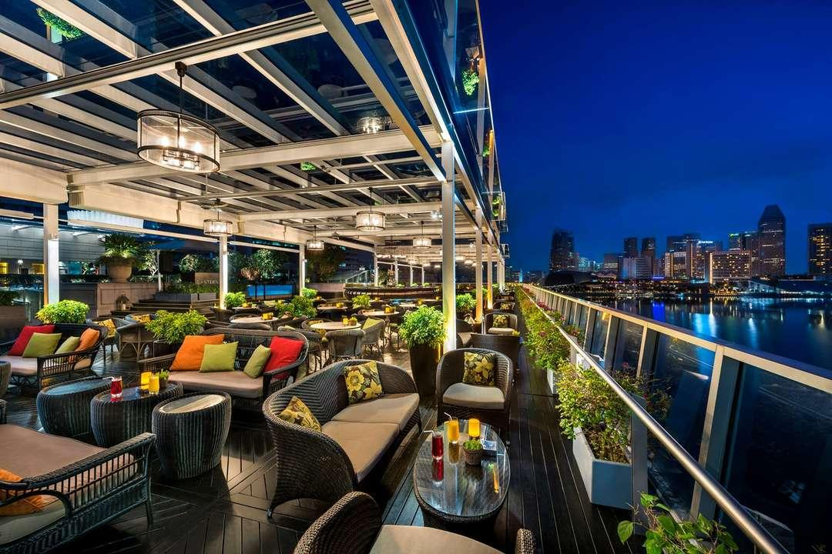
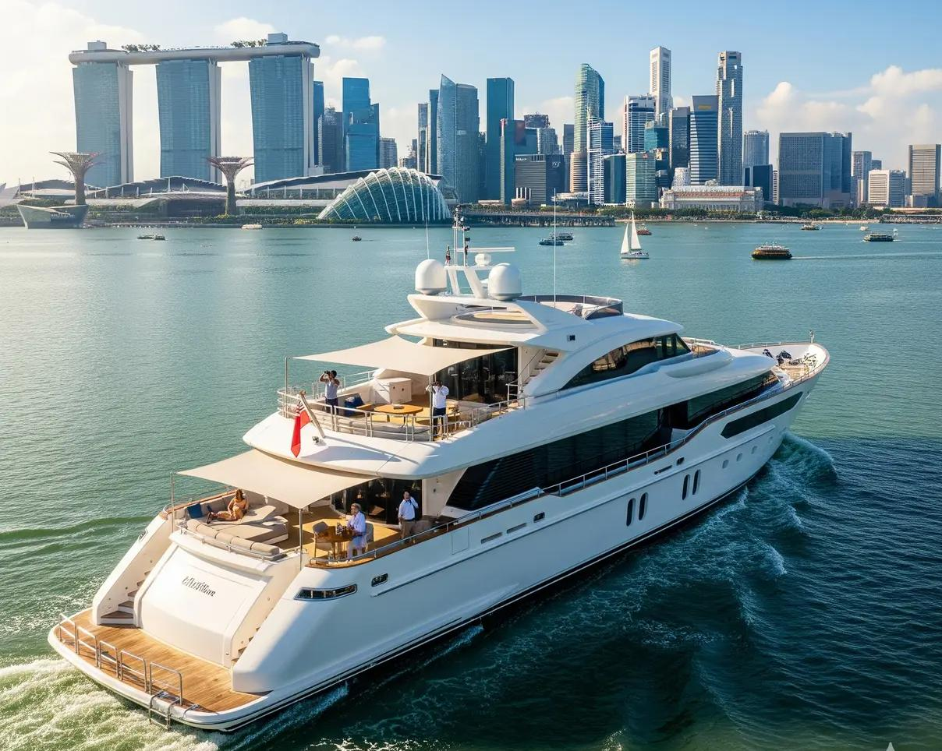
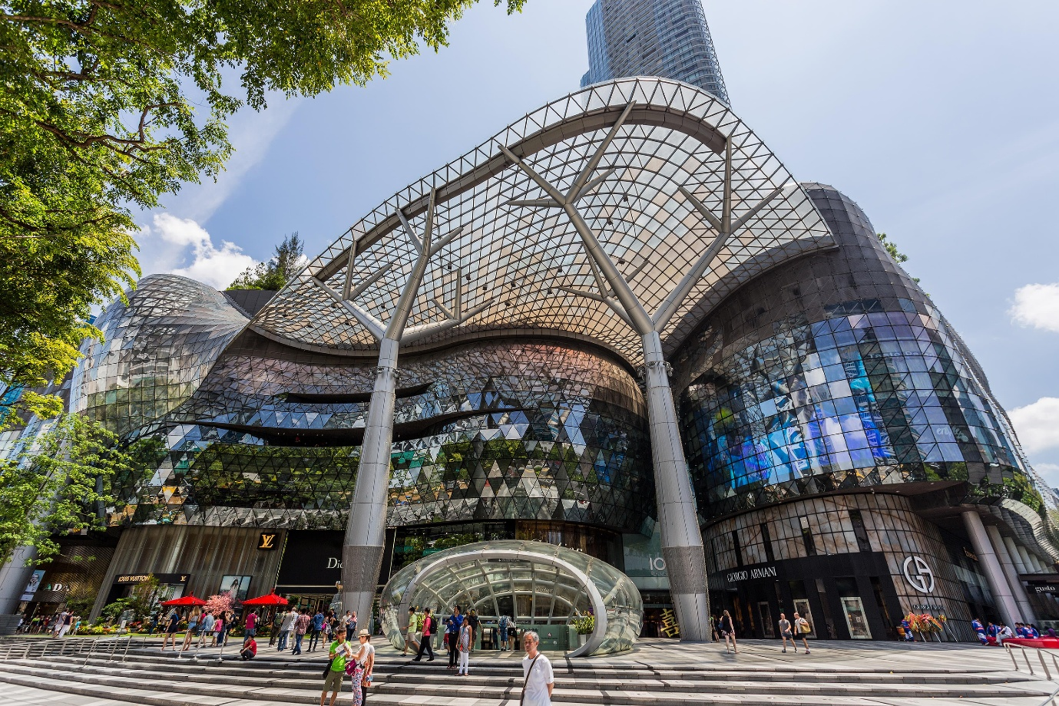

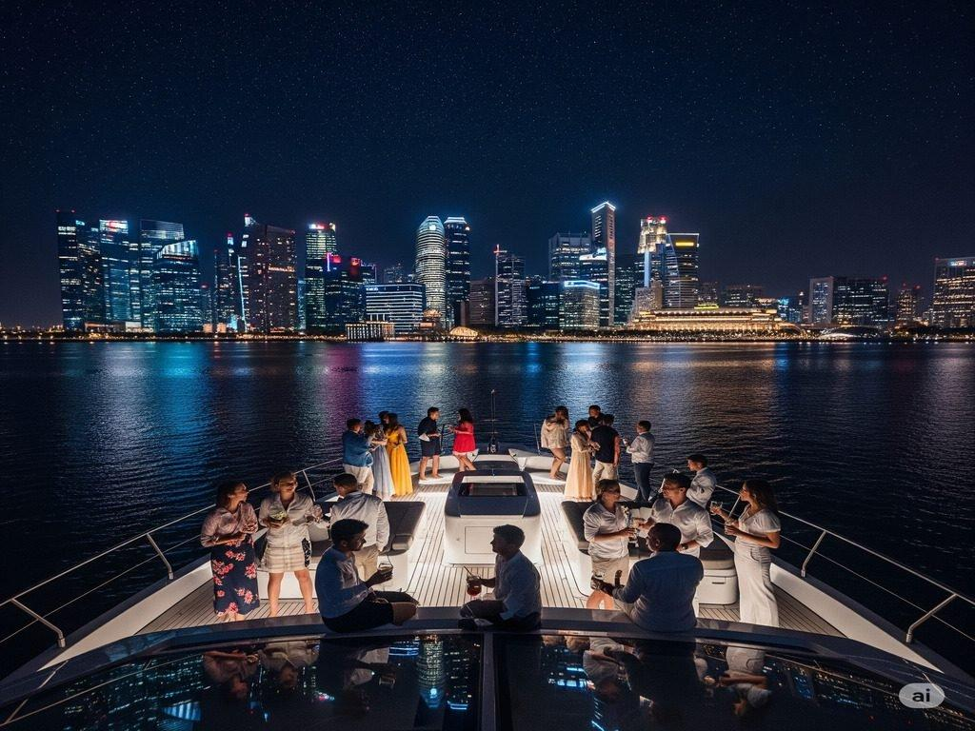

Singapore Travel Tips
- Follow Singapore’s strict cleanliness laws
- Avoid chewing gum in public areas
- Use MRT trains for easy travel
- Carry light cotton clothing
- Keep an umbrella for sudden rain
- Book attractions online in advance

Why Choose INTRO TRAVELS INDIA for Singapore?
With INTRO TRAVELS INDIA, you get:
- Customized Singapore holiday packages
- Family & honeymoon tours
- Budget & luxury hotel options
- Visa assistance
- Airport transfers
- Guided sightseeing tours
- Attraction ticket bookings
- Indian meal options
- Group departures & private tours
Singapore is the perfect destination where luxury, entertainment, modern architecture, nature, and adventure come together to create a world-class travel experience.

